|  |
| --- |
| American Video Game Company |
| Software Project |
| C188 Performance Assessment |

|  |
| --- |
| Nicholas Fuller  7-20-2022  [Version 1.2] |

Contents

A. INTRODUCTION 3

A.1. Purpose Statement 3

A.2. Overview of The Problem 3

A.3. Goals and Objectives 3

A.4. Prerequisites 3

A.5. Scope 4

A.6. Environment 4

B. REQUIREMENTS 5

B.1. Business Requirements 5

B.2. User Requirements 5

B.3. Functional Requirements 5

B.4. Nonfunctional Requirements 6

C. SOFTWARE DEVELOPMENT METHODOLOGY 7

C.1. Advantages of the waterfall method 7

C.2. Disadvantages of the waterfall method 7

C.3. Advantages of The Agile Method 7

C.4. Disadvantages of the Agile Method 7

C.5. Best Suited 7

D. DESIGN 9

D.1. Database UML Diagram 9

D.2. GUI 10

E. TESTING 12

E.1. Black-Box Testing 12

E.1.1. Add Contacts Test 12

E.1.2. Reorder Testing 13

E.1.3. Contract Termination Testing 14

# INTRODUCTION

A CRM (Customer Relationship Management) is a tool that allows an organization to collect and store data about customer interactions in one place. CRMs drive growth and profits. Additionally, the gathered data helps businesses improve customer service, satisfaction, and retention.

# A.1. Purpose Statement

The purpose of this document is to provide information on the requirements, software development methodology, design, and testing of the proposed CRM.

# A.2. Overview of The Problem

The current system includes a disconnected set of custom-built tools in spreadsheet software, and many manual steps and processes. The tools are spread across multiple offices and team members working remotely. The lack of a unified system and tools, including the lack of automated processes, needs to be addressed by the new proposed CRM system.

# A.3. Goals and Objectives

To provide a system that:

* Consolidates all contact and business information.
* Reports the company’s activities and interactions with contacts.
* Controls access to features based on roles and permissions for the company’s users, both internal and remote.
* Enables access to the system by 3rd party marketing companies under contract.
* Manages activities and tracks sales.
* Integrates with other systems to allow for sharing of data.
* Has robust security.
* Can be enhanced and scaled.

# A.4. Prerequisites

|  |  |  |  |
| --- | --- | --- | --- |
| Number | Prerequisite | Description | Completion Date |
| 1 | Operating System | Update all PCs to the latest Windows 10. This is needed to ensure the highest level of security and avoid the end of official Microsoft support for Windows 8.1 on January 10, 2023. This also ensures compatibility with the latest Chrome, Chromium, and Firefox browsers. | 9/30/2022 |
| 2 | Operating System | Update all Mac Operating Systems to the latest version (Must be macOS 10.12 or later). This is needed to ensure compatibility with Chrome, Chromium, and Firefox browsers, as well as ensure the highest levels of performance and security. | 9/30/2022 |
| 3 | Hardware | Upgrade all PC Desktop workstations to Intel 15 10000+ series CPUs. This is needed to ensure that problems with current, older systems are minimized in the short term and for the business’ transition to Windows 11 before the official Microsoft support end date of October 14, 2025. | 6/30/2023 |

# A.5. Scope

The proposed solution will cover the implementation of new systems that will help the American Video Game Company have more unified and complete processes for all parts of their business. Current databases will remain, and the new system will be designed to attach to and enhance the current databases and systems. Additions to current systems will be focused on automating and simplifying processes already in use by AVGC. The new system will be more useful and malleable and serve AVGC for years to come.

# A.6. Environment

The proposed solution will be deployed to existing Core i5 desktop systems and laptop and Apple systems initially. Soon after, all hardware will be updated to Windows 11 supporting hardware. The proposed application will be built using Java. Databases will be hosted on-site by the American Video Game Company.

# REQUIREMENTS

5 key requirements of the proposed system are:

* Soft and hard delete.
* Support about 500 concurrent users peak while meeting performance standards.
* Delivery of both predefined and custom reports.
* Forecasting / predicting sales and revenue.
* Order management/ordering and completing sales

# Business Requirements

* We must ensure that users’ access to hard delete is restricted to appropriate roles and permissions and that all data is preserved historically and supports rollback.
* We need our CRM to handle peak times effectively and support all users performantly to avoid business delays and downtime.
* Our CRM should deliver regular reports quickly and custom reports easily.
* The CRM needs to predict sales and revenue accurately to ensure the right business direction.
* Order management in the CRM needs to be simple, informative, secure, and reliable to drive continued engagement.

# User Requirements

* Soft deletions need to be easily accessible to users and confirm the user’s choice before deleting. hard delete should only appear for users with the appropriate permissions and should not appear in any form for regular users.
* Users require the CRM to operate smoothly and timely, with no downtime, especially during peak business hours.
* Reports need to be generated quickly when requested by the user. Custom reporting tools need to be robust and easy to read/use.
* Forecasting reports should be legible and simple, and scalable to different roles (i.e., one for stakeholders, another for teams that work in depth with the data, etc.).
* Users require that orders be simple to complete and that customers be filtered through self-service ordering options initially.

# Functional Requirements

* The CRM displays and supports soft delete for all users and only offers hard delete to users with permissions.
* The CRM easily supports over 500 users accessing and altering data at once and will support more with growth over time.
* The CRM can send automated daily, weekly, monthly, etc. reports. reports of all predefined types should be provided in what feels like “on-demand” time. custom reports should be easily accessible and constructed.
* The CRM predicts sales and revenue accurately and is easily configurable to different audiences.
* The CRM provides robust order automation. orders are easily added, found, or edited through the CRM.

# Nonfunctional Requirements

* The CRM maintains historical records and supports full rollbacking.
* The CRM will scale and support thousands of users at one time in the future.
* The CRM can deliver several predefined reports with a few clicks, and custom reports can be created very efficiently and easily.
* The CRM can generate forecast reports at any time and should deliver them quickly
* The CRM has availability for customers at all hours through automated self-serve options. Customer service can help customers manually through the CRM during business hours.

# SOFTWARE DEVELOPMENT METHODOLOGY

The company has selected the waterfall software development methodology for this project. This will be compared to the Agile development methodology, a RAD (Rapid Application Development) strategy. The key advantages and disadvantages of each will be discussed below.

# Advantages of the waterfall method

* The Waterfall method can save the business money by only implementing what is in the design documentation, ensuring resources are not wasted on the development of cut / unfruitful features.
* With everything being designed upfront, the Waterfall method allows only the fully designed plan to be worked on, making programming faster.
* The Waterfall method contains better documentation, allowing all programmers (including newbies / new hires) to get and maintain a better footing.

# Disadvantages of the waterfall method

* The Waterfall method lacks the flexibility to adapt to changing requirements or new opportunities, this can lead to an entire project being redone or shelved.
* The Waterfall method only allows the business to release a finished product, there are no / fewer opportunities to iterate or improve.
* The Waterfall method requires that the entire design be signed off on before any work can start. This forces resources to remain idle for an extended period.

# Advantages of The Agile Method

* The Agile method supports more accurate requirements, allowing the development of the project to change with changing customer requirements.
* Frequent customer feedback drives user engagement and keeps the project on track.
* The Agile method reduces development time by encouraging code reuse and not having to spend time writing detailed requirements.

# Disadvantages of the Agile Method

* The Agile method may struggle to handle larger systems well, as there are a lot of communication and resource needs.
* The Agile method requires skilled programmers, this can limit the ability to hire or maintain enough resources for the project.
* The Agile method can result in a design that is not optimal, due to its iterative and changing nature, as opposed to having all requirements set in stone.

# Best Suited

The need for this project to have the ability to be “enhanced and scaled” in the future is reason enough to switch the development of this project to the Agile development method. With Agile, we will be able to provide the customer with prototypes fast and adapt to their changing needs during development. This will allow us to work closely with the customer and deliver a CRM that meets their expectations, and hopefully, exceeds them in some ways. If we were to stick with the Waterfall method for this project, we would deliver a product to the customer that they may or may not be fully satisfied with. Using Agile, we will position ourselves to be the customer’s prime candidate to handle the roadmap and future iterations of this project, extending our business with the customer for years to come.

# DESIGN

Below are descriptions and visual representations of both the database and Order Tracking view of the application’s GUI.

# Database UML Diagram

The UML diagram below shows how people, organizations, and businesses are represented in the database. All the data here is dependent on the Stakeholder data type. All Contacts and Businesses are Stakeholders. A Business may have contacts. A Business has at least 1 Address and at least 1 Phone Number. Optionally, an Address may have Phone Numbers associated with it.

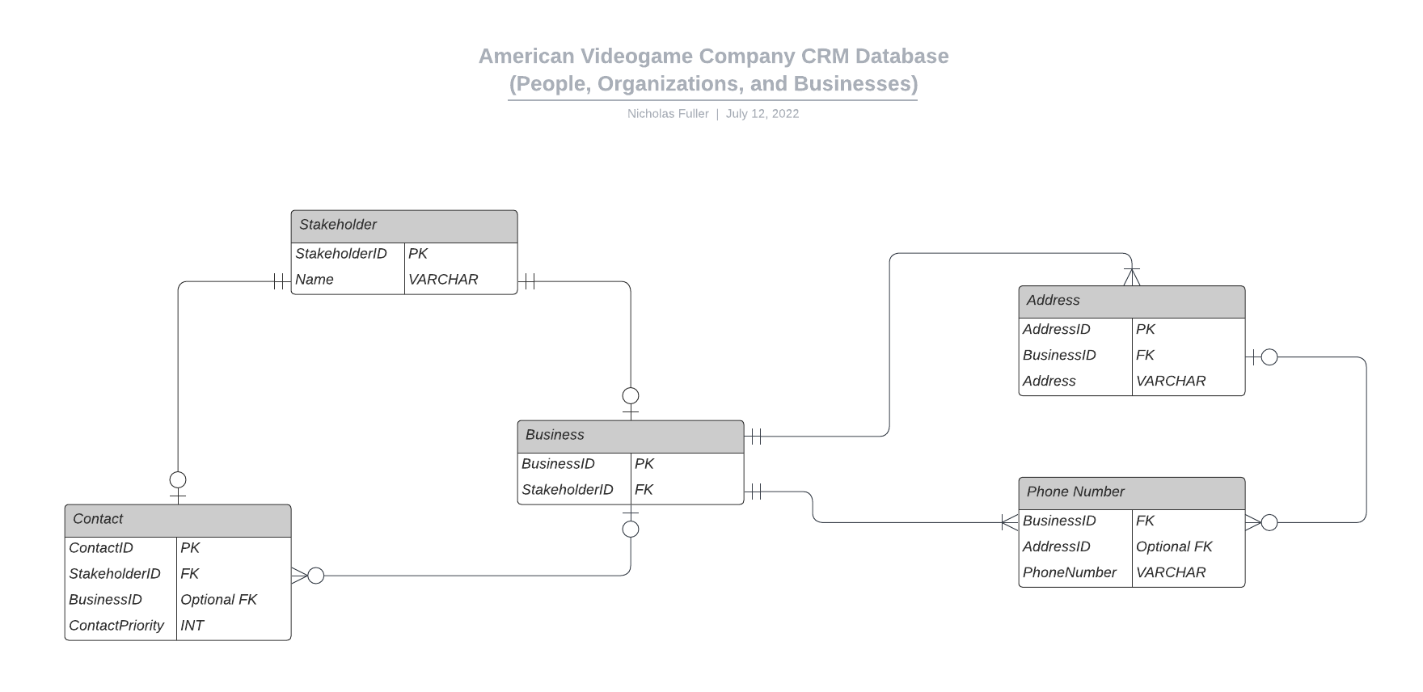

Figure 1: American Videogame Company CRM Database (People, Organizations, and Businesses)

# GUI

Below is a mock-up of the proposed GUI of the Order Tracking view of the desktop application. Included is a GUI control mapping.

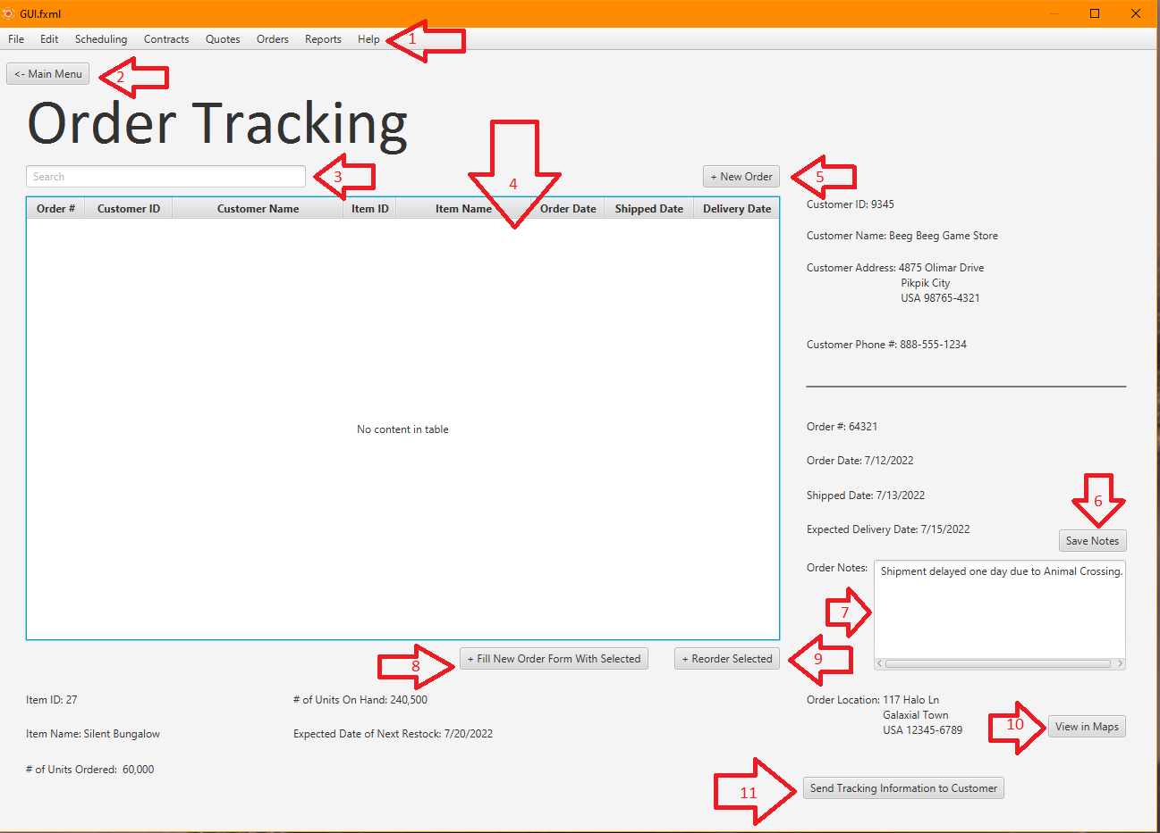

Figure 2: Order Tracking View Mock-up of Proposed Application GUI

|  |  |  |  |
| --- | --- | --- | --- |
| GUI Control Mapping | | | |
| ID | Control | Property | Data Source |
| 1 | MenuBar | On click, open the selected Menu | Selected Menu |
| 2 | Button | On click of Button, change the view to Main Menu | View Controller |
| 3 | TextField | On click, place cursor in Search Field | N/A |
| 3 | TextField | When the cursor is in Search Field, on a key being pressed, begin searching all data for entered String | Internal Variable |
| 4 | TableView | On view open, populate TableView with all orders in the database | Database |
| 4 | TableView | On click of header button, filter column in ascending/descending order | Database |
| 4 | TableView | On click of row, display order information in various Labels | Database |
| 5 | Button | On click, open a New Order Form | View Controller |
| 6 | Button | On click, save information in Order Notes TextArea to Database | Database |
| 7 | TextArea | On view open, populate TextArea with appropriate data from the database | Database |
| 7 | TextArea | On click, place cursor in TextArea | N/A |
| 7 | TextArea | When the cursor is in TextArea, on a key being pressed, enter keypress into TextArea | Internal Variable |
| 8 | Button | On click, open New Order Form Populated with selected order data | View Controller |
| 9 | Button | On click, the order is duplicated exactly and placed as a new order | Internal Variable |
| 10 | Button | On click, opens a map application and displays delivery location, stops, handoffs, and point of origin | External Application |
| 11 | Button | On click, opens and populates a new email to the customer with relevant tracking information, email must then be sent from an external application | External Application |

# TESTING

Below is a description of Black-Box Testing and 3 black-box tests.

# Black-Box Testing

Black-Box Testing is done by pretending a method is a black box that you cannot look inside. We know what the method does, but not how it does it. Many inputs are given to the method and the results are evaluated for correctness.

# Add Contacts Test

|  |
| --- |
| We will test that adding contacts to the system produces correct results. |
| Preconditions: Testing software must be loaded onto a capable machine, which must be connected to the intranet/internet and system database. |
| Steps:   1. Test adding 100 randomly generated contacts. 2. Verify that each contact was added correctly without any errors or data corruption. 3. Attempt to submit multiple contacts with bad data (missing names, non-existent businesses, etc.) 4. Verify that each contact was not added to and blocked by the system. |
| Expected results: The system is expected to handle all 100 contact adds without issue. The system is expected to reject all contacts submitted with bad data. |
| Pass/Fail: Pass. |

# Reorder Testing

|  |
| --- |
| We will test that reordering using the system produces the expected results. |
| Preconditions: The CRM application is loaded onto a standard company desktop and connected to a dummy/test database filled with dummy/test order data (thousands of orders). |
| Steps:   1. Tester logs into the application. 2. The tester reorders all orders in the system that meet the criteria for reordering (using automated scripts). 3. Verify that all reorders were successfully placed as new orders. 4. Tester attempts to reorder all orders that do not meet the criteria for reordering (using automated scripts). 5. Verify that the system does not allow the tester to reorder any of the attempted reorders that do not meet reordering criteria. |
| Expected results: All the reorders that were placed that meet the criteria for reordering are expected to be placed as new orders without any errors or issues. All the reorders that were placed that do not meet the criteria for reordering are expected to be rejected by the application and/or system. |
| Pass/Fail: Fail. |

# Contract Termination Testing

|  |
| --- |
| We will test that contracts are terminated on time automatically and can be terminated manually. |
| Preconditions: The CRM application is loaded onto a standard company desktop and connected to the test database. |
| Steps:   1. Add 1000 contracts to the system, each with a termination time 6 hours later than the last beginning with 6 hours from the current time (using automated scripts). 2. Change the time of the test database to 6000 hours in the future. 3. Verify that all 1000 added contracts were successfully terminated. 4. Add another 1000 contracts to the system, each with a termination time 6 hours later than the last beginning with 6 hours from the current time (using automated scripts). 5. Terminate all 1000 contracts manually (using automated scripts). 6. Verify that all 1000 added contracts were successfully terminated. |
| Expected results: All the first 1000 added contracts are expected to terminate on time without issue. All the second 1000 added contracts are expected to be terminated manually without issue. |
| Pass/Fail: Pass. |